Zheng, Zhi

Zhizheng0889@floridapoly.edu

Project: Forecasting the future of Miami All Employee & Average Weekly Wage

Time Series & Forecasting Analysis for Business

Abstract

Forecasting is an old but always important field of study for humanity. Forecasting is the study of predicting what possibly can happen in the future, it can be appl-y on daily subject like daily weather to annually prediction of global economics to decade long prediction for disaster. Thus, it is an ever-expanding field of study t-hat can be endlessly improved on. In the study below I am doing a forecasting for each of the monthly change for All Employees: Total Private in Miami-Fort Lauderdale-West Palm Beach, FL (MSA) and Average Weekly Earnings of All Employees: Total Private in Miami-Fort Lauderdale-West Palm Beach, FL (MSA)

1. Vselect models for forecasting All Employees: Total Private in Miami-Fort Lauderdale-West Palm Beach, FL (MSA)

After testing many different models with different predicators, the best variables to use with forecasting All Employees in Miami-Fort Lauderdale-West Palm Beach, FL (MSA) are first differenced & logged All Employees, Labor Force and Unemployment ratio in Miami-Fort Lauderdale-West Palm Beach, FL (MSA). After running the vselect to estimate and evaluate the models with 12-Lags for each predictor variables, the results are:



Then, I selected models from #Preds 4-10 as the best models, because model 4 have the best BIC score and model 10 have the best AIC score. Finally, I ran regression on these models plus a simple 12-lag AR model to get LOOCV RMSE and other calculations to get a table summarization. The result is shown below:



The 12-lag AR simple model have the lowest LOOCV RMSE result, the model 5 have best BIC result, and model 8 have best AIC result. In conclusion, Model 5 are the best fit model other than the 12-lag AR model.

After picking the best fit models from vselect process, then I use rolling window technique on 5 different models (Model 12-Lag, and Model 5 to Model 8) based on the best AIC and BIC to make final model selection for finding the best out of the best fit models with the best prediction window width. The best rolling window rmse result for these models are:

|  |  |  |
| --- | --- | --- |
| Models | Best Window Width (By Month) | RMSE |
| Model 12-Lag: | 180 | .03774197 |
| Model 5: | 180 | .04004232 |
| Model 6: | 180 | .04157896 |
| Model 7: | 180 | .03921726 |
| Model 8: | 180 | .03858189 |

After comparing the rmse of each model, the 12-Lag AR only model (reg d.lnAllEmployees l(1/12)d.lnAllEmployees m2 m3 m4 m5 m6 m7 m8 m9 m10 m11 m12) have the best rmse, however this model is a benchmark model, I won’t be using it for forecasting in this study. Thus, the Model 8 (reg d.lnAllEmployees l(1, 2, 7)d.lnAllEmployees l(1, 4, 9)d.lnUnemRate l(5, 6)d.lnLabF m2 m3 m4 m5 m6 m7 m8 m9 m10 m11 m12) have the second best rmse at the window width of 180 months. In conclusion, the model 8 is the best model at the window width at 180 months (15 years).

1. Vselect models for forecasting Average Weekly Earnings of All Employees: Total Private in Miami-Fort Lauderdale-West Palm Beach, FL (MSA)

After testing many different models with different predicators, the best variables to use with forecasting Average Weekly Earnings in Miami-Fort Lauderdale-West Palm Beach, FL (MSA) are first differenced & logged Average Weekly Earnings, Average Hourly Earnings and Average Weekly Hours in Miami-Fort Lauderdale-West Palm Beach, FL (MSA). After running the vselect to estimate and evaluate the models with 12-Lags for each predictor variables, the results are:

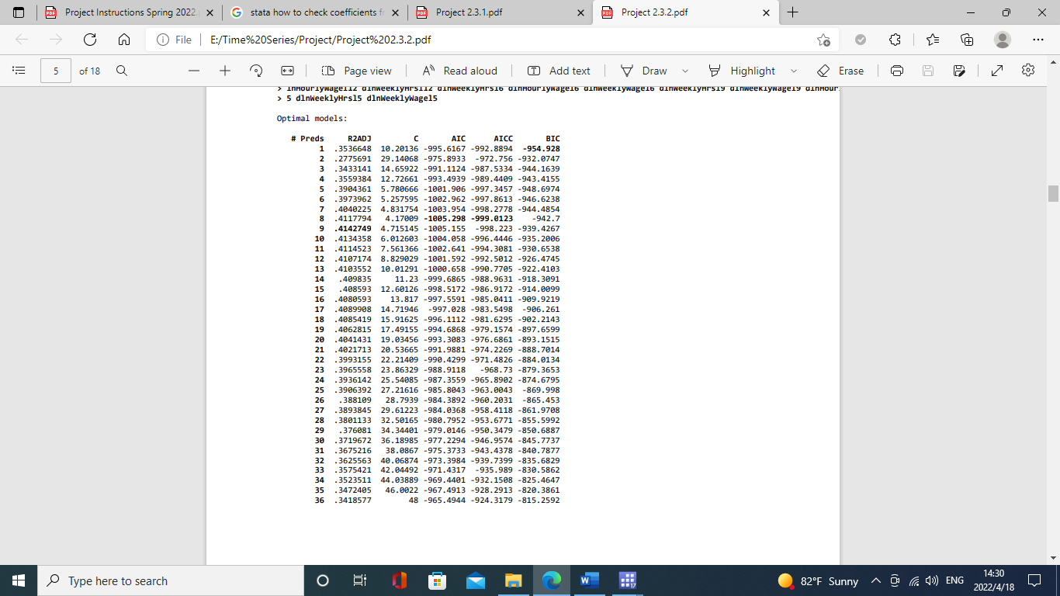

Then, I selected models from #Preds 1-8 as the best models, because model 1 have the best BIC score and model 8 have the best AIC score. Finally, I ran regression on these models plus a simple 12-lag AR model to get LOOCV RMSE and other calculations to get a table summarization. The result is shown below:



The Model 8 have the lowest LOOCV RMSE result and AIC result, the Model 5 have BIC result. In conclusion, Model 5 are the best fit model because it has the best information criterion scores (BIC) and the simplest model.

After picking the best fit models from vselect process, then I use rolling window technique on 5 different models (Model 12-Lag, and Model 5 to Model 8) based on the best AIC and BIC to make final model selection for finding the best out of the best fit models with the best prediction window width. The best rolling window rmse result for these models are:

|  |  |  |
| --- | --- | --- |
| Models | Best Window Width (By Month) | RMSE |
| Model 12-Lag: | 132 | .01332579 |
| Model 5: | 72 | .01285895 |
| Model 6: | 72 | .01334716 |
| Model 7: | 72 | .01295601 |
| Model 8: | 72 | .01278424 |

After comparing the rmse of each model, the Model 8 (reg d.lnWeeklyWage l(1, 2, 5, 6)d.lnWeeklyWage l(9, 11)d.lnWeeklyHrs l(7, 10)d.lnHourlyWage m2 m3 m4 m5 m6 m7 m8 m9 m10 m11 m12) have the best rmse at the window width of 72 months (6 years).